CrowSoft Database Design

# CrowSoft Use Case

The use case below is base on CrowSoft functional requirements.

* Users require creating an account, and can either be an Admin, Employee or Customer user.
* User requires to login into the system and the system needs to validate what role the user belongs to
* A customer/client user can create a building quote for analysis and costing. The customer can upload multiple images and also select custom features to be added to the costs.
* The Admin user can add default building features for analysis and costing
* An admin user can review the building analysis and costing, update changes to the costs/features and apply the costing again, or approve the costs.

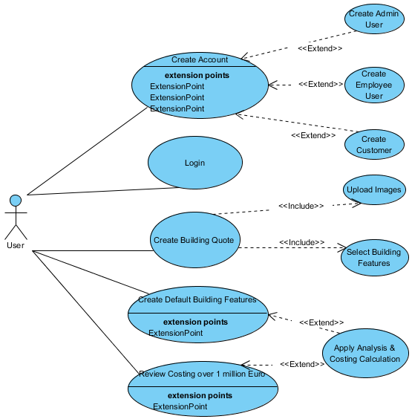

## CrowSoft Database Table Structures

### CrowSoft ERD

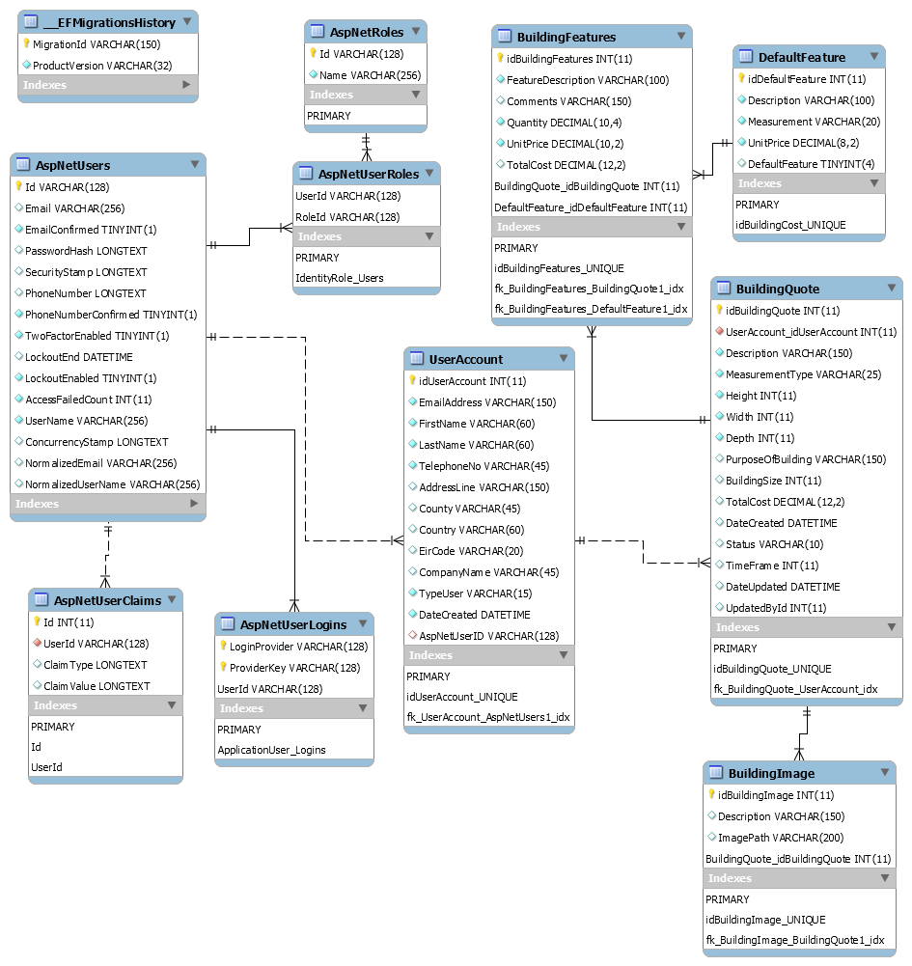

### Asp.Net Identity Security Tables

Microsoft introduced ASP.Net Identify Security for use by an ASP.Net Core MVC application. This security identity enables a role-based security, hidden/hash passwords and also prevents cross site scripting, SQL injections, and much more. The reason for choosing this method is ensure users are allocated to a specific role.

The following table are required for ASP.Net Core Identity Manager:

* AspNetUsers
  + This table stores the main user when registered on the web site
  + It also store passwords using Microsoft’s internal hashing algorithm. The following hashing format is used: PBKDF2 with HMAC-SHA256, 128-bit salt, 256-bit subkey, 10000 iterations
  + A sign-in cookie is used when a user login
* AspNetRoles
  + To store roles in the database assigned to users
  + Roles: Client, Admin and User
* AspNetUserRoles
  + This table is the reference table of what users belong to which roles.
  + Many-to-many between AspNetUsers and AspNetRoles
* AspNetUserLogins (Not in use)
  + This table is used when using OAuth for storing other provider information such as Google, Facebook or Microsoft.
* AsoNetUserClaim (Not in use)
  + This is normally use when a user have claims in more than one application. We do not need to use this table.

### User Account Table

This table will be used for multipurpose users; for employees, admin users and customers. This will use a role-base security at three levels, admin (all access), employee user (access to view costing and building quotes), customer (allow to create building quote including features). Features on the UI will be visible according to the role of the user.

|  |  |  |  |  |  |
| --- | --- | --- | --- | --- | --- |
| **Column Name** | **Description** | **Mandatory** | **Sample Data** | **Validation** | **type** |
| idUserAccount | Primary Key - Auto Increment | Y | 1 |  | int |
| EmailAddress | Email Address and Username | Y | [joe@email.com](mailto:joe@email.com) | Valid Email Address | string |
| Password | Hash Password using Cryptography in ASP.Net Core before saving to DB | Y | $1$O3JMY.Tw$AdLn | Validate Login | string |
| FirstName | First Name | Y | Joe | Not null | string |
| LastName | Last Name | Y | Blogg | Not null | string |
| TelephoneNo | Telephone No | Y | 555-555-5555 | Not null | string |
| AddressLine1 | Address Line 1 | N | 123 Street |  | string |
| AddressLine2 | Address Line 2 | N | My Area |  | string |
| County | County | N | Donegal |  | string |
| Country | Country | N | Ireland |  | string |
| EirCode | Postal Code | N | F90 A1A1 |  | string |
| CompanyName | CompanyName | Y | CrowSoft | Not null | string |
| TypeUser | Drop Down Box (Admin, Employee, Customer) | Y | Admin | Not null | string |
| DateCreated | Auto Generated by MySQL (CURRENT_TIMESTAMP`) | Y | 2019-02-31 20:00:00' | Not null | DateTime |
| AspNetUserID | Foreign Key column for AspNetUsers table | Y | GUID String 142331f4-23d2-4835-9b77-b6a3d38223a2 | Not null | string |

### Default Feature Table

The default feature table is a configuration table for both default features to be added to each and every building quote, but also where a customer can select multiple features to be added to the quote and to be calculated.

|  |  |  |  |  |  |
| --- | --- | --- | --- | --- | --- |
| **Column Name** | **Description** | **Mandatory** | **Sample Data** | **Validation** | **type** |
| idDefaultFeature | Primary Key - Auto Increment | Y | 1 |  | int |
| Description | Description of the Feature | Y | E.g. Concrete Walls, Kitchen, Tiled Roof | Not null | string |
| Measurement | Type of measurement used to calculate unit price | Y | E.g. Qty, Time, Sqr Meters, Sqr Foot | Not null | string |
| UnitPrice | Unit Price of feature | Y | €100.00 | Not null | int |
| DefaultFeature | This is a Boolean field. If this field = 1, then this feature will be automatically be added to the total cost, if 0, then it will display as an option for the customer to select. | Y | 1 or 0 | Not null | tinyint |

### Building Quote Table

This is the header table when a customer creates a new quote for costing. A user/customer has to register for an account before they can create a quote for costing. A separate process will automatically run when a customer click confirms. This calculation will add up all default and customer features required and add it to the total cost.

|  |  |  |  |  |  |
| --- | --- | --- | --- | --- | --- |
| **Column Name** | **Description** | **Mandatory** | **Sample Data** | **Validation** | **type** |
| idBuildingQuote | Primary Key - Auto Increment | Y | 1 |  | int |
| UserAccount_idUserAccount | Many to One Foreign Key to UserAccess Table | Y | 1 | User has to be logged in | int |
| Description | Description of the building the customer requires | Y | Offices for Joe Blogg | Not null | string |
| MeasurementType | Drop Down for Metrics or Imperial | Y | Metric | Not null | string |
| Height | Height | Y | 50 | Not null | int |
| Width | Width | Y | 200 | Not null | int |
| Depth | Depth | Y | 200 | Not null | int |
| PurposeOfBuilding | Customer explains purpose of the building | N | Office Block |  | string |
| BuildingSize | Calculated from Height, Width and Depth | N |  | Auto calculation | int |
| TotalCost | System calculates total cost of all features | N | €130,000.00 | If cost is over €1 mill, change status to Withhold | decimal |
| DateCreated | Auto Generated by MySQL (CURRENT_TIMESTAMP) | Y | 2019-02-31 20:00:00' | Not null | datetime |
| Status | Status of the quote: Confirmed, Approved, Withhold, Cancelled | Y | Approved | Not null | string |
| TimeFrame | This is the time in months. Calculated from labour cost. | N | 6 | Auto calculation | decimal |
| DateUpdated | Updated when record is updated by Admin | N | 2019-02-31 20:00:00' |  | datetime |
| UpdatedBy | Admin Id who updated the qoute | N | 1 |  | int |

### Building Features Table

This table is to save the customer selected features to be added to the final costing.

|  |  |  |  |  |  |
| --- | --- | --- | --- | --- | --- |
| **Column Name** | **Description** | **Mandatory** | **Sample Data** | **Validation** | **type** |
| idBuildingFeatures | Primary Key - Auto Increment | Y | 1 |  | int |
| Comments | Comments of whats required | N | Colour of the walls white |  | string |
| FeatureDescription | Copied from default feature select |  | Concrete | Auto generate from default features selected | string |
| Quantity | Qty required | Y | 150 | Not null | int |
| UnitPrice |  | Y | €50 | Not null | decimal |
| TotalCost | Total cost calculated | N | €7,500 | Auto calculate | decimal |
| BuildingQuote_idBuildingQuote | Foreign key for building quote | Y | 1 | Not null | int |
| DefaultFeature_idDefaultFeature | Foreign key for Default Feature | Y | 1 | Not null | int |

### Building Image Table

The customer will be able to upload multiple images and this is where the image path will be stored. This has a many to one relationship with the Building Quote header table.

|  |  |  |  |  |  |
| --- | --- | --- | --- | --- | --- |
| **Column Name** | **Description** | **Mandatory** | **Sample Data** | **Validation** | **type** |
| idBuildingImage | Primary Key - Auto Increment | Y | 1 |  | int |
| Description | Image Description | Y | Building Plans |  | string |
| ImagePath | Path of the folder where images is stored | Y | d:/crowsoft/images | Auto generate filename | string |
| BuildingQuote_idBuildingQuote | Foreign key for building qoute | Y | 1 | Not null | int |